Python is an [**interpreted**](https://en.wikipedia.org/wiki/Interpreted_language), [**high-level**](https://en.wikipedia.org/wiki/High-level_programming_language), [**general-purpose**](https://en.wikipedia.org/wiki/General-purpose_programming_language) [programming language](https://en.wikipedia.org/wiki/Programming_language).

Created by [**Guido van Rossum**](https://en.wikipedia.org/wiki/Guido_van_Rossum) and first released in 1991,

Other features Includes:

* [Dynamically typed](https://en.wikipedia.org/wiki/Dynamic_programming_language) and [garbage-collected](https://en.wikipedia.org/wiki/Garbage_collection_(computer_science)).
* Supports multiple [programming paradigms](https://en.wikipedia.org/wiki/Programming_paradigm),
  + [Procedural](https://en.wikipedia.org/wiki/Procedural_programming)
  + Object-Oriented and
  + [functional programming](https://en.wikipedia.org/wiki/Functional_programming).

Python Release:

The implementation of Python was started in the December 1989 by **Guido Van Rossum** at CWI in Netherland.

In February 1991, van Rossum published the code (labelled version 0.9.0)

Python 1.0 was released on January 1994. With new features like:

* lambda, map, filter, and reduce.

Python 2.0 was released on 16 October 2000. With new features.

* list comprehensions
* [Cycle-detecting](https://en.wikipedia.org/wiki/Cycle_detection) [garbage collector](https://en.wikipedia.org/wiki/Garbage_collection_(computer_science)) and
* support for [Unicode](https://en.wikipedia.org/wiki/Unicode)

Python 3.0 was released on 3 December 2008. Major revision of the language includes

* 2to3 utility, which automates (at least partially) the translation of Python 2 code to Python.

Python Latest Release:

* 2.x – 2.7.16 March 4, 2019
* 3.x – 3.7.4 July, 2019

Program to Process

# include <stdio.h>

# include <stdlib.h> b

int x = 20;

int main(){

int a = 10;

int *ptr;

while(1){

ptr = (int*) malloc(sizeof(int) * 10);

}

free(ptr);

return 0;

}

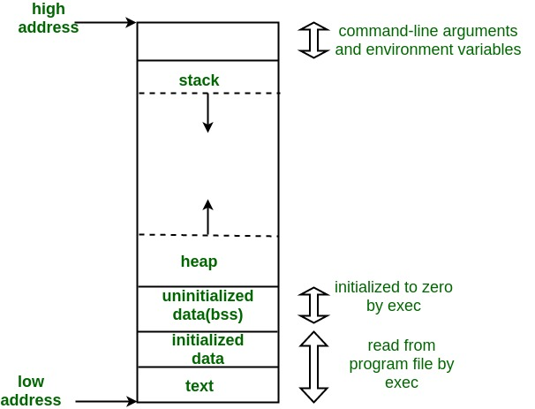

Notes:

C does not provide garbage collection (run time memory management) feature. So, user(developer) must take responsibility. Otherwise it creates memory leaks.

Python is having a VM which monitors the memory allocation and deallocation to private heap. So, no memory leaks

Why Python is Interpreted language?